I will get different celebrities in the programming business to come along to code games, websites and anything else, they will also help normal programmers and coders with their projects and offer insights and tips to improve what they are doing.

I will advertise this by putting up posters in the local area and get a section in the local newspaper detailing the whole event, have a billboard and use social networks to spread the word. Each celebrity could endorse my product and appear on each of the advertising methods.

1. **Marketing Mix**

This will fit into my marketing mix as it is relevant to programing.

**Place:** I will do this in a big building like the private room of a local library or an office space with an internet connection.

**Price:** This will be free to the public and I will have to pay for the celebrities and the publicity but I will get allot of money back from it.

**Product:** This will be to promote my website designs and hosting.

1. **Product/Service**

**Legal Aspects:** “Code.Session_48” Copyright Of KTB Designs

**Appeal:** People are generally sociable and will enjoy exchanging ideas and methods of programming along with the aspect of helping one another.

**Appropriateness:** Although there is no clear aim we will get allot of publicity do to the fact that we will have celebrities to endorse the product. This also links into my company as it to do with coding as i make websites.

1. **Logo:**

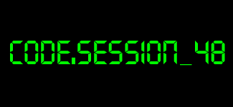

**Values:** Helping others, programming and coding.

**Recognisable:** The colour and font make people link this to .Terminal or the command prompt on computers which are the main area on which programming was first used this helps people to relate this to the .

**Colours/feelings:** Black background with green text which represents the typical terminal/coding text which people think of.

1. **Website Design:**

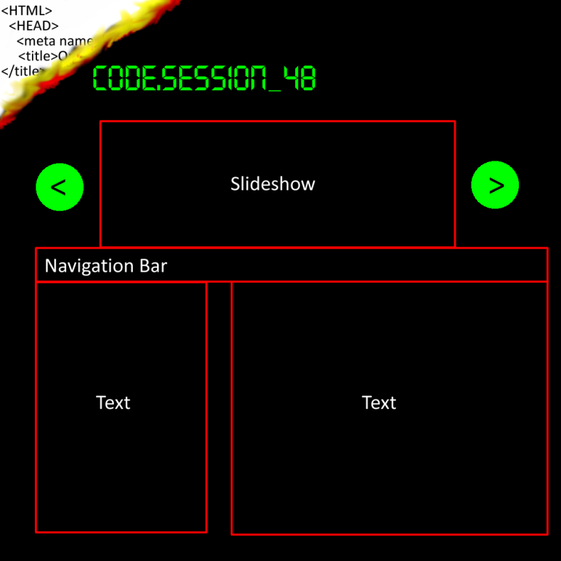

**Purpose:** To inform people of the event.

**Functionality:** Informing via text and video.

**The Look:** I will have continuity in fonts and the theme across the website.

**How to get people to the website:**  The Link will be on social networks and on the billboards and newspaper article.

The website will be alongside my website and not a standalone website because it will help draw attention to my website, helping my business get attention and popularity. It is important to have the website as it will draw attention to my business and supply information for the event.

1. **Images to be developed:**

**What does it portray?** I will use pictures of each celebrity involved to attract the attention of people, they will be in different stances to show different aspects of the event, such as having arms folded to show power or on a computer to show intelligence.

**Choosing images to suit your brand:** These celebrities are well established in the industry and well known and respected among programmers and coders alike.

I will need to have images on billboards with the celebrity and contact information, i will also need to have images for social networks.

1. **Cost and schedule of campaign:**

**When will the campaign start?** This campaign will begin on the 4th of May 2013

**How long will it run for?** This will run for 48 hours.

**Which resources are needed and when?** We will need a strong internet connection and multiple projectors to showcase the projects that have been made. We will also need to have posters, magazine and billboard adverts made for promoting the event.

**Is there anything that could stop or delay it? And how could this be avoided?** We could not find the right building in time or there could be health and safety issues, this could be avoided by planning and checking with the right people beforehand.

**How and when will you evaluate the campaign?** I will measure the number of sales after this event and for the next few months to see if there is an increase in sales.

1. **Type of promotional materials:**

Buying Habits: People who have an idea or product that they want to promote or share would like a website to do so. This market is also seen as the business market.

**Where will they look for information?** Mainly on billboards, social networking sites.

1. **Nature of the promotional material:**

**Colours:** Bold, effective and reflect the campaign, these will be in the similar colour to the CMD on windows, these will be black and Neon-Green.

**Images/graphics:** Simple and basic ideas are most effective with a theme of computing so I will use .

**Wording:** Clear and concise, to the point so no time is wasted nothing much is needed to be said except for the information on what where and when this will be.

**Text:** Bold and in eye catching colours such as Neon-Green which also reflect the main theme of the event.

**Messages:** To have fun and to enjoy this event.

1. **Reason why promotional material is appropriate:**

I will get celebrities such as Mark Zuckerberg made famous for creating Facebook, Markus (Notch) Persson famous for making Minecraft and Darren Kitchen who is a popular on youtube. These are good people to get as they will help the people who come to the event and work across different programming platforms such as Java, HTML and Bash.

There is a social aspect where people get to share their knowledge and experience., to help others and to show off ideas and innovations.

1. **How you will measure the success of the promotion:**

I will measure this by the amount of people who come to the event and the amount of clients I have 6 months after the event compared with before the event. If there are is a substantial increase I will deem this event as successful, if there is not a reasonable or no increase I will deem this as being an unsuccessful event.